National Textile University, Faisalabad

Department of Computer Science
Name: | Muhammad Haseeb
Class: | BSCS 6th (Section – B)
Registration No: | 23-NTU-CS-1069
Assignment: | 02
Course Nae: | Web Development
Submitted To: | Mr. Zahid
Submission Date: | March 04 – 2026

Landing Page
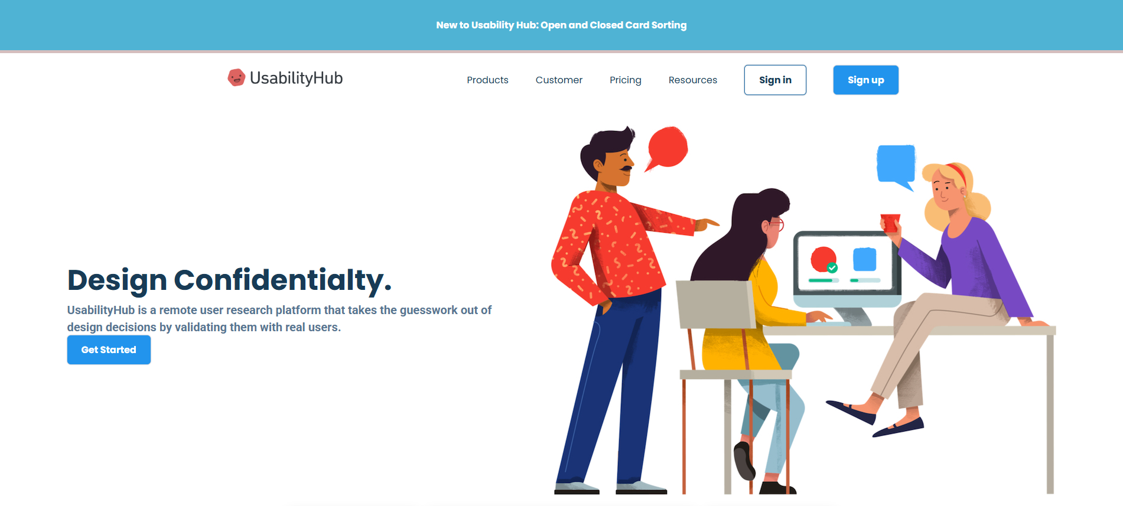

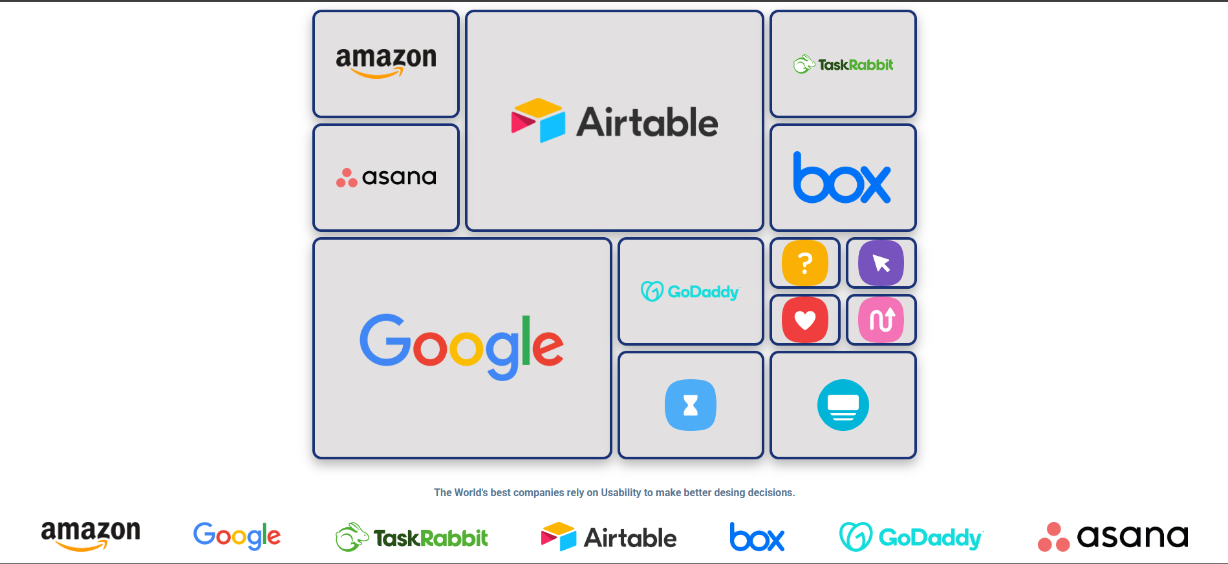

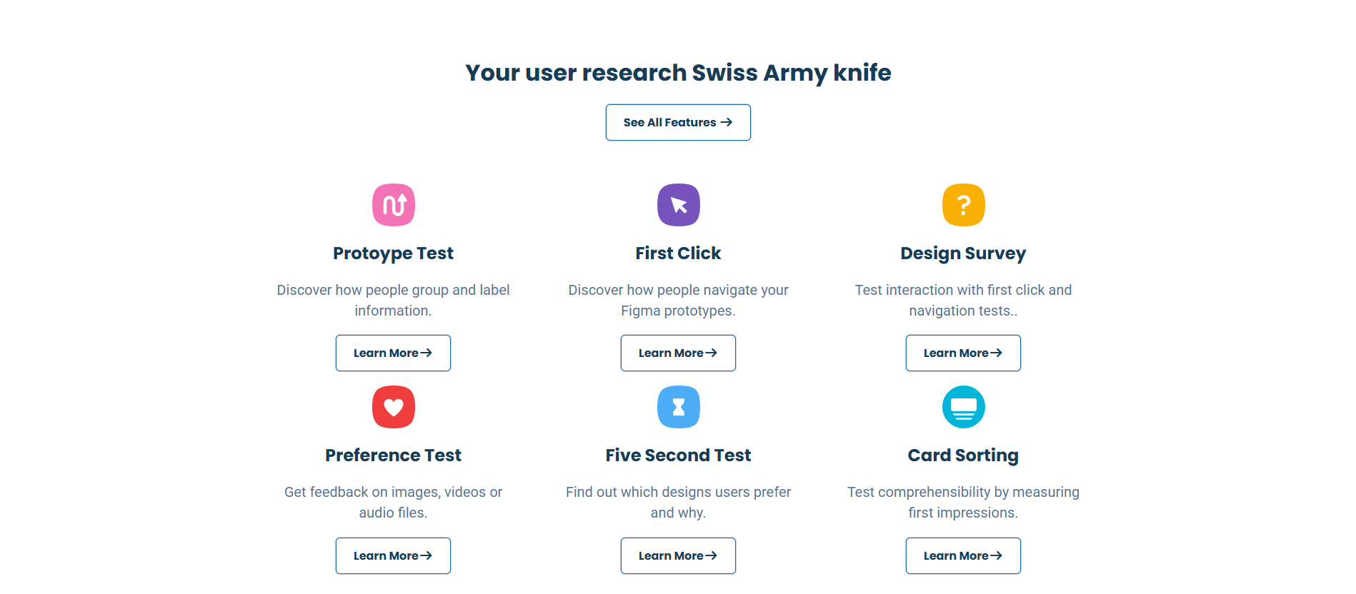

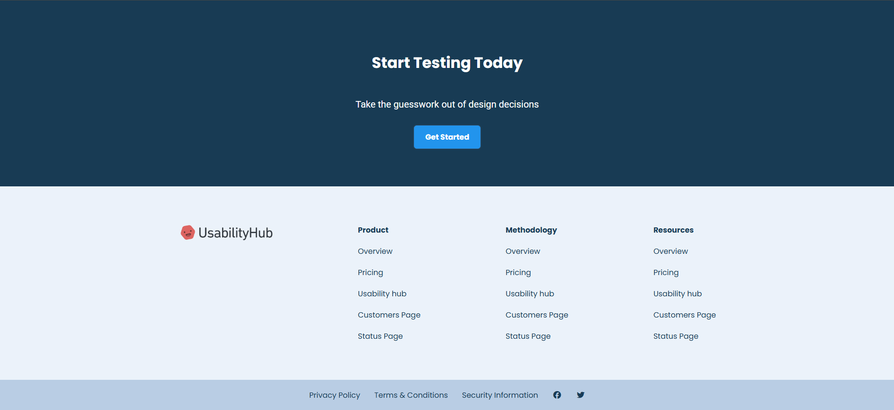

HTML
<!DOCTYPE html>
<html lang="en">
<head>
<meta charset="UTF-8">
<meta name="viewport" content="width= device-width, initial-scale=1.0">
<title>My Website</title>
<link rel="stylesheet" href="style.css">
<link rel="stylesheet" href="media-queries.css">
</head>

<body>
<!-- Top Banner -->
<div class="top-banner">
<div class="container banner-text">
<div class="small-bold-text banner-text">New to Usability Hub: Open and Closed Card Sorting</div>

</div>
</div>

<!-- Nav -->
<nav>
<div class="container main-nav flex">
<a href="#" class="company-logo">
<img src="./images/logo_favicontoo.png" alt="company logo">
</a>
<div class="nav-links" id="nav-links">
<ul class="flex ul main-ul">
<li><a href="#" class="hover-links">Products</a></li>
<li><a href="#" class="hover-links">Customer</a></li>
<li><a href="#" class="hover-links">Pricing</a></li>
<li><a href="#" class="hover-links">Resources</a></li>
<li><a href="#" class="secondary-btn">Sign in</a></li>
<li><a href="#" class="primary-btn">Sign up</a></li>
</ul>
</div>
<a href="javascript:void(0)" class="nav-toggle hover-link" id="toggle">
<i class="fa-solid fa-bars"></i>
</a>
</div>

</nav>
<!-- header -->
<header>
<div class=" container-header flex">
<div class="headerleft">
<h1>Design Confidentialty.</h1>
<p>UsabilityHub is a remote user research platform that takes the guesswork out of design decisions by validating them with real users.</p>
<a href="#" class="primary-btn">Get Started</a>
</div>
<div class="headerRight">
<img src="./images/big feature image 1.jpg" alt="">
</div>

</div>
</header>

<!-- Section -->
<section>
<div style="display: flex; justify-content: center;">

<table width="50%" cellspacing="8" cellpadding="0"
style="border-collapse: separate;">

<!-- 8 equal columns -->
<colgroup>
<col span="8" style="width:12.5%;">
</colgroup>

<!-- ROW 1 -->
<tr style="height:80px">
<td colspan="2" rowspan="2" ><img src="./images/amazon logo (1).png"></td>
<td colspan="4" rowspan="4" ><img src="./images/airtable (1).png"></td>
<td colspan="2" rowspan="2" ><img src="./images/taskrabbit (1).svg"></td>
</tr>

<!-- ROW 2 -->
<tr style="height:80px"></tr>

<!-- ROW 3 -->
<tr style="height:80px">
<td colspan="2" rowspan="2""><img src="./images/asana (1).png"></td
<td colspan="2" rowspan="2""><img src="./images/box (1).png"></td>
</tr>

<!-- ROW 4 -->
<tr style="height:80px"></tr>

<!-- ROW 5 -->
<tr style="height:80px">
<td colspan="4" rowspan="4"><img src="./images/google logo (1).png"></td>
<td colspan="2" rowspan="2"><img src="./images/godaddy (1).png"></td>
<td> <img src="./images/design survey.svg"></td>
<td> <img src="./images/first click.svg"></td>
</tr>

<!-- ROW 6 -->
<tr style="height:80px">
<td ><img src="./images/preference test.svg"></td>
<td ><img src="./images/Prototype test.svg"></td>
</tr>

<!-- ROW 7 -->
<tr style="height:80px">
<td colspan="2" rowspan="2"><img src="./images/five second test.svg"></td>
<td colspan="2" rowspan="2"><img src="./images/Card sorting.svg"></td>
</tr>

<!-- ROW 8 -->
<tr style="height:80px"></tr>

</table>
</div>

</section>

<section >
<div class="container">
<p class="small-bold-text tsection">The World's best companies rely on Usability to make better desing decisions.</p>
</div>
<div class="logo-section">
<img class="logo" src="./images/amazon logo (1).png" alt="12">
<img class="logo" src="./images/google logo (1).png" alt="12">
<img class="logo" src="./images/taskrabbit (1).svg" alt="12">
<img class="logo" src="./images/airtable (1).png" alt="12">
<img class="logo" src="./images/box (1).png" alt="12">
<img class="logo" src="./images/godaddy (1).png" alt="12">
<img class="logo" src="./images/asana (1).png" alt="">
</div>
</section>

<!-- Feature Section -->
<section class="features-section">
<div class="container">
<div class="features-header">
<h2>Your user research Swiss Army knife</h2>
<a href="#" class="secondary-btn fbtn">See All Features <i class="fa-solid fa-arrow-right"></i></a>
</div>

<div class="features-area flex">
<div class="feature-card flex">
<img src="./images/Prototype test.svg" alt="">
<h3>Protoype Test</h3>
<p>Discover how people group and label information.</p>
<a href="#" class="secondary-btn"> Learn More<i class="fa-solid fa-arrow-right"></i></a>
</div>

<div class="feature-card flex">
<img src="./images/first click.svg" alt="">
<h3>First Click</h3>
<p>Discover how people navigate your Figma prototypes.</p>
<a href="#" class="secondary-btn"> Learn More<i class="fa-solid fa-arrow-right"></i></a>

</div>
<div class="feature-card flex">
<img src="./images/design survey.svg" alt="">
<h3>Design Survey</h3>
<p>Test interaction with first click and navigation tests..</p>
<a href="#" class="secondary-btn"> Learn More<i class="fa-solid fa-arrow-right"></i></a>

</div>
<div class="feature-card flex">
<img src="./images/preference test.svg" alt="">
<h3>Preference Test</h3>
<p>Get feedback on images, videos or audio files.</p>
<a href="#" class="secondary-btn"> Learn More<i class="fa-solid fa-arrow-right"></i></a>

</div>
<div class="feature-card flex">
<img src="./images/five second test.svg" alt="">
<h3>Five Second Test</h3>
<p>Find out which designs users prefer and why.</p>
<a href="#" class="secondary-btn"> Learn More<i class="fa-solid fa-arrow-right"></i></a>

</div>
<div class="feature-card flex">
<img src="./images/Card sorting.svg" alt="">
<h3>Card Sorting</h3>
<p>Test comprehensibility by measuring first impressions.</p>
<a href="#" class="secondary-btn"> Learn More<i class="fa-solid fa-arrow-right"></i></a>

</div>
</div>
</div>
</section>

<section class="big-feature-section"></section>

<section class="big-feature-section"></section>

<section class="big-feature-section"></section>

<section class="examples-section"></section>

<section class="cta-section">
<div class="container flex cta-section-container">
<h2>Start Testing Today</h2>
<p>Take the guesswork out of design decisions</p>
<a href="#" class="primary-btn">Get Started</a>
</div>
</section>

<footer>
<div class="container flex footer-container">
<a href="#" class="company-logo">
<img src="./images/logo_favicontoo.png">
</a>
<div class="link-column flex">
<h4>Product</h4>
<a href="#" class="hover-links">Overview</a>
<a href="#" class="hover-links">Pricing</a>
<a href="#" class="hover-links">Usability hub</a>
<a href="#" class="hover-links">Customers Page</a>
<a href="#" class="hover-links">Status Page</a>
</div>

<div class="link-column flex">
<h4>Methodology</h4>
<a href="#" class="hover-links">Overview</a>
<a href="#" class="hover-links">Pricing</a>
<a href="#" class="hover-links">Usability hub</a>
<a href="#" class="hover-links">Customers Page</a>
<a href="#" class="hover-links">Status Page</a>
</div>

<div class="link-column flex">
<h4>Resources</h4>
<a href="#" class="hover-links">Overview</a>
<a href="#" class="hover-links">Pricing</a>
<a href="#" class="hover-links">Usability hub</a>
<a href="#" class="hover-links">Customers Page</a>
<a href="#" class="hover-links">Status Page</a>
</div>
</div>
</footer>

<div class="subfooter">
<div class="container flex subfooter-container">
<a href="#" class="hover-links">Privacy Policy</a>
<a href="#" class="hover-links">Terms & Conditions</a>
<a href="#" class="hover-links">Security Information</a>
<a href="#" class="hover-links"><i class="fa-brands fa-facebook"></i></a>
<a href="#" class="hover-links"><i class="fa-brands fa-twitter"></i></a>

</div>
</div>

<script src="https://kit.fontawesome.com/ff3ddf7c87.js" crossorigin="anonymous"></script>

<script>
const toggleButton = document.getElementById('toggle');
const navlinks = document.getElementById('nav-links');

toggleButton.addEventListener('click', ()=>{
navlinks.classList.toggle('active');
})
</script>

</body>
<script src="Practice.js"> </script>

</html>

CSS:
@import url('https://fonts.googleapis.com/css2?family=Poppins:ital,wght@0,100;0,200;0,300;0,400;0,500;0,600;0,700;0,800;0,900;1,100;1,200;1,300;1,400;1,500;1,600;1,700;1,800;1,900&family=Roboto:ital,wght@0,100..900;1,100..900&display=swap');

* {
margin: 0;
padding: 0;
box-sizing: border-box;
}

:root {
--primary-text-color: #183b56;
--secondary-text-color: #577592;
--accent-color: #2294ed;
--accent-color-dark: #1d69a3;
--padding-inline-section: 20px;
}

body {
font-family: 'Poppins',sans-serif;
color: var(--primary-text-color);
}

h1 {
font-size: 3rem;

}
h2 {
font-size: 2rem;
}
h3 {
font-size: 1.5rem;
}

p {
font-family: 'Roboto',sans-serif;
font-size: 1.25rem;
color: var(--secondary-text-color);
line-height: 1.8rem;
}

a {
text-decoration: none;
display: inline-block;
}
table{
margin-top: 10px;
}
td {
text-align: center; /* horizontal center */
vertical-align: middle; /* vertical center */
border-radius: 14px;
border:solid 4px #1A3376;
background-color: #E2E0E0;
box-shadow: 0 8px 18px rgba(0,0,0,0.3);
}
td img {
max-width: 70%;
max-height: 70%;
object-fit: contain;
display: block;
margin: auto;
}
td:hover {
transform: translateY(-8px);
}

/* Utility CLass */

.flex {
display: flex;
align-items: center;
}
.small-bold-text {
font-size: 1rem;
font-weight: 700;
}

.container {
max-width: 1180px;
margin-inline: auto;
padding-inline: var(--padding-inline-section);
}

.ul{
list-style: none;
}

.hover-links{
color: var(--primary-text-color);
}
.hover-links:hover{
color: var(--accent-color);
transition: 0.2s ease-out;
}

.primary-btn{
background-color: var(--accent-color);
border-radius: 6px;
/* border: 0.5px solid var(--accent-color-dark); */
font-weight: 700;
padding: 12px 24px;
color: white ;
box-shadow: 0 0 2px var(--secondary-text-color);
}
.primary-btn:hover{
background-color: var(--accent-color-dark);
transition: 0.2s ease-out;
}
.secondary-btn{
background-color: white;
border-radius: 6px;
border: 0.5px solid var(--accent-color-dark);
font-weight: 700;
padding: 12px 24px;
color: var(--primary-text-color) ;
box-shadow: 0 0 2px var(--secondary-text-color);
}
.secondary-btn:hover{
/* color: var(--accent-color-dark); */
transition: 0.2s ease-out;
background-color: #2294ed;
color: white;
}
/* Top Banner */
.top-banner {
background-color: #4fb3d4;
border-bottom:5px solid #D4BEBE;
}

.banner-text {
color: white;
padding: 15px 30px;
text-align:center;
}

/* nav */
.main-nav{
justify-content: space-between;
margin-top: 20px;
position:relative;
}
.company-logo img {
width: 200px;
}
.main-ul{
justify-content: space-between;
gap: 40px;
}
.nav-links{
flex-basis: 730px;
}
.nav-toggle {
display: none;
}

/* header */
.container-header{
padding: 50px var(--padding-inline-section) 0;
justify-content: center;
gap:50px
}

.headerleft{
font-weight: 700;
color: var(--primary-text-color);
gap: 50px;
max-width: 40vw;
}
.headerRight img{
width: 100%;
}

/* Header Section */
.tsection{
text-align: center;
margin-block: 30px;
}
.logo-section{
display: flex;
justify-content: space-evenly;
gap:20px;
flex-wrap: wrap;

}
.logo{
height: 46px;

}

/* Feature Section */
.features-section{
padding: 80px var(--padding-inline-section) 0;
/* background-image: url(./images/26055ac39cd00944266e45a2799260e4.jpg); */
background-repeat: no-repeat ;
background-position: center;
}
.features-header{
text-align: center;
margin-bottom: 40px;
}
.fbtn{
margin-bottom:20px;
margin-top: 20px;

}
.feature-card{
flex-direction: column;
gap: 20px;
max-width: 30%;
text-align: center;
}
.feature-card img{
width:60px;
}
.features-area{
flex-wrap: wrap;
justify-content: space-between;
gap: 20px;
margin-top: 20px;
}

/* CTA */
.cta-section {
background-color: #183b54;
padding: 120px var(--padding-inline-section) 80px;
margin-top: 30px;
}
.cta-section-container {
flex-direction:column;
gap:30px;
color: white;
background-color: #183b54;
}

.cta-section-container p{
color: white;
margin-top: 20px;
}

/* Footer */
footer{
padding-block: 80px;
background-color: #ebf2fa;;
}
.link-column {
flex-direction: column;
align-items: flex-start;
gap:20px;
}

.footer-container {
align-items: flex-start;
justify-content: space-between;
}

/* Subfooter */
.subfooter{
background-color: #b9cde4;
padding: var(--padding-inline-section);
}

.subfooter-container {
justify-content: center;
gap: 30px;
}

